**Milestone 11: Bank Entries**

Activity 1: Recording of Bank Transactions

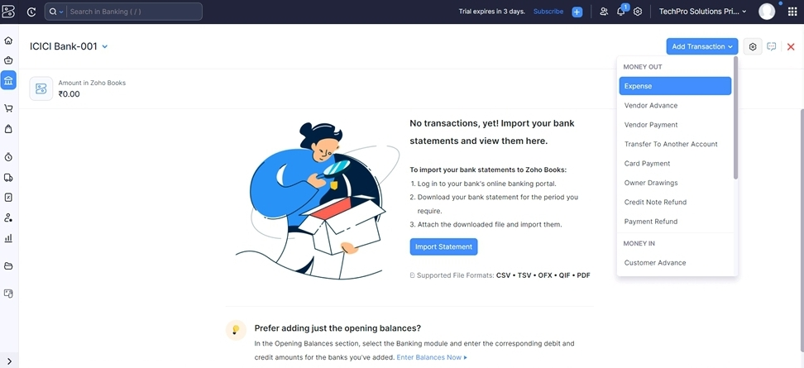

For Vendor Payment:

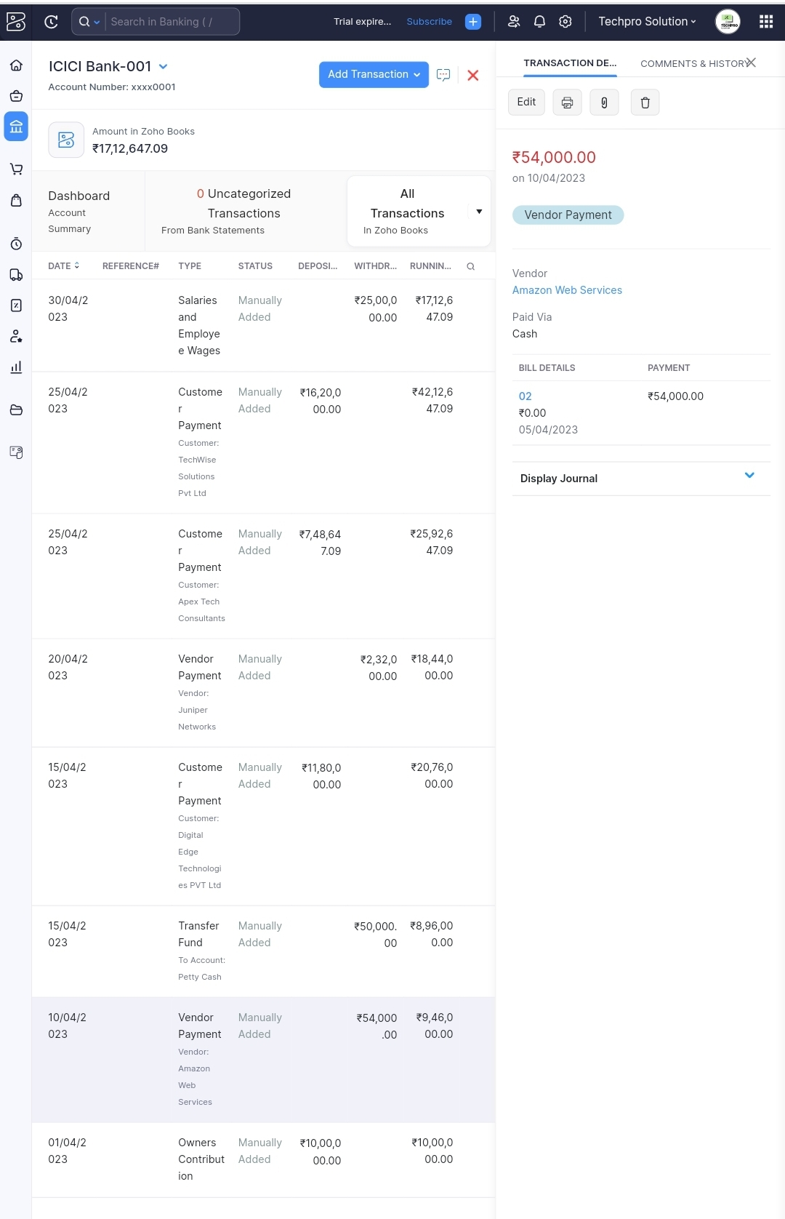

For Customer Payment: 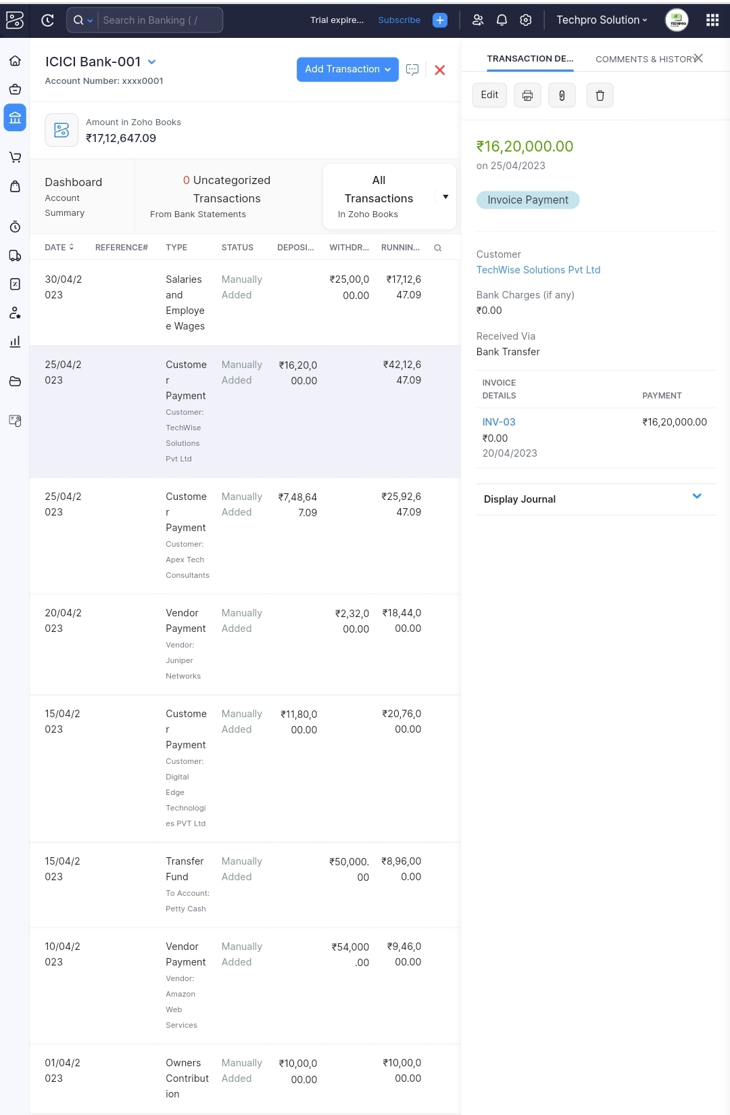

For Salary Payment Record Journal Entry

